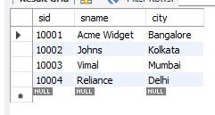 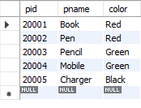

Supplier table Parts Table

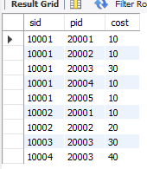

Catalog Table

**Query 1 : Find the pnames of parts for which there is some supplier.**

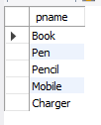

**Query 2: Find the snames of suppliers who supply every part.**

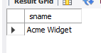

**Query 3: Find the snames of suppliers who supply every red part.**

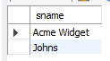

**Query 4: Find the pnames of parts supplied by Acme Widget Suppliers and by no one else.**

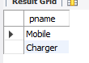

**Query 5: Find the SIDs of suppliers who charge more for some part than the average cost of that part (averaged over all the suppliers who supply that part).**

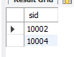

**Query 6: For each part, find the sname of the supplier who charges the most for that part.**

